**Develop a python script**

|  |  |
| --- | --- |
| Team ID | PNT2022TMID03883 |
| Project Name | Smart waste management system for metropolitan cities |

SPRIT 3 SCREEN SHOTS FOR SIMULATOR

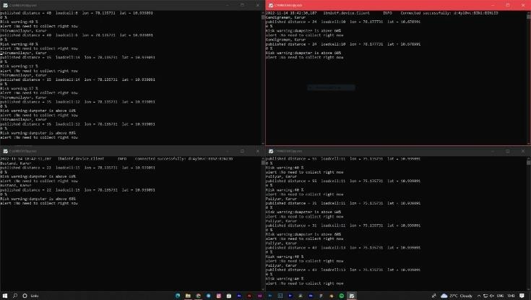

TEAM ID : PNT2022TMID03883

TEAM ID : PNT2022TMID03883

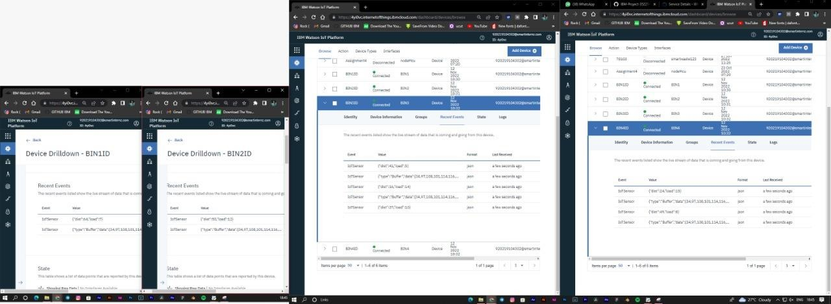

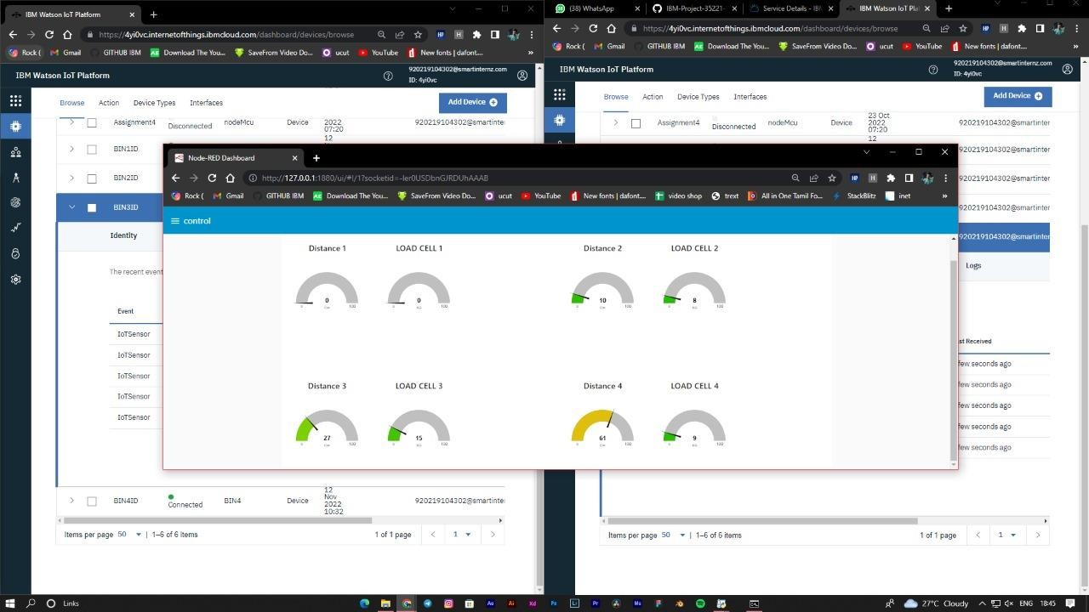

TEAM ID : PNT2022TMID03883

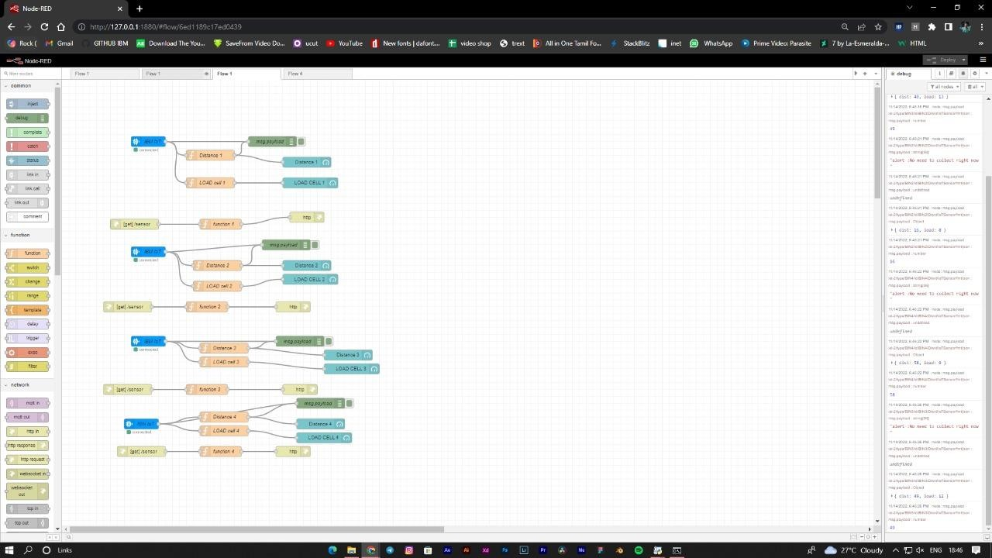

TEAM ID : PNT2022TMID03883

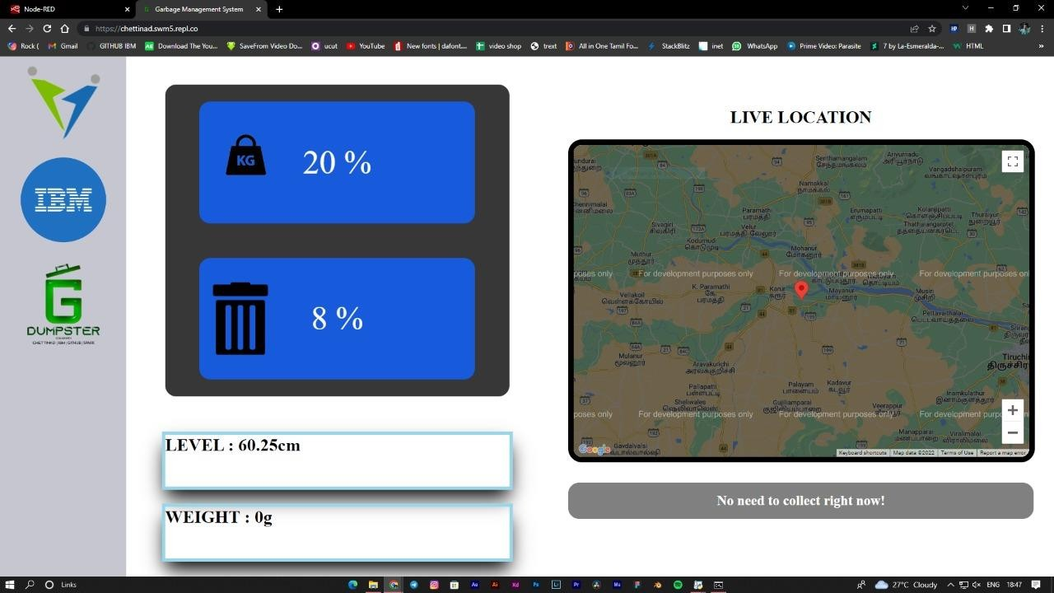

TEAM ID : PNT2022TMID03883